**WSK-72-W1S1K3**

**Temperature & Humidity Controller**

**User Manual**

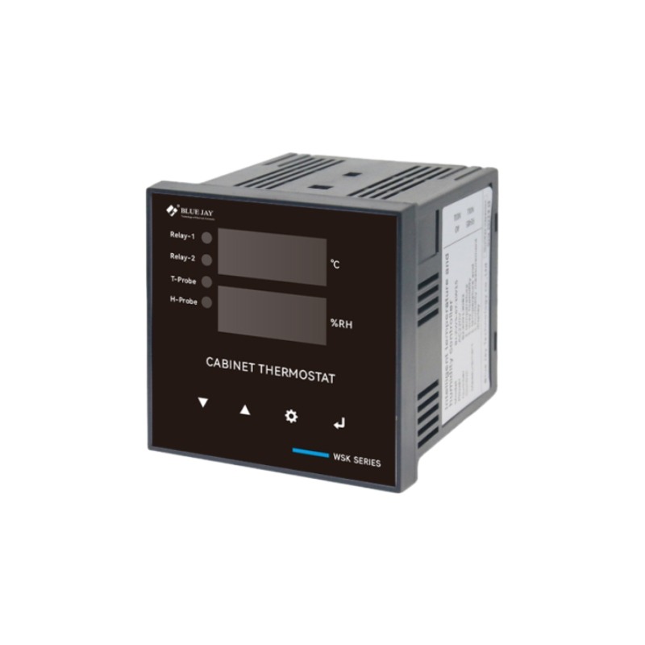

**Version: 1.10**

**Revision: 2024-11**

**Read me**

**When you use WSK-72 Series Digital-type Temperature & Humidity controller, be sure to carefully read this user manual, and be able to fully understand the implications, the correct guidance of operations in accordance with user manual, which will help you make better use WSK-72 series Temperature &Humidity controller, and help to solve the various problems at the scene.**

1. Before the meter turning on the power supply, be sure that the power supply within the

provisions of the instrument;

2. When installation, the current input terminal must non-open, voltage input terminals must

Non-short circuit;

3. Communication terminal (RS485) is strictly prohibited to impose high pressure;

4. Be sure the instrument wiring consistent with the internal system settings;

5. When communicating with the PC, instrument communication parameters must be consistent with the PC.



* **Please read carefully before using this user manual**
* **Please save this document**

**Directory**

1.- SUMMARIZE 1

2.- FEATURES 1

3.- SPECIFICATIONS 2

4.- INSTALLATION AND START-UP 3

**4.1.- Mounting** 3

**4.2.- Connection Drawing for the WSK-72-W1S1K3** 4

5.- OPERATION MODE 2

6.- SETUP PROCEDURE 3

**6.1.- Password enter** 3

**6.2.- Temperature control value** 4

**6.3.- Humidity control value** 5

**6.4.- Control mode setting** 6

**6.5.- Communication setting** 6

**6.6.- Temperature alarm setting** 7

7.- SAFETY CONSIDERATIONS 8

8.- MAINTENANCE 8

# **1.- SUMMARIZE**

WSK-72 Series Temperature and Humidity Controller is a measurement device used on temperature and humidity control. and the humidity control module is integrated in the system, greatly improving the suitability of the equipment, obtaining the temperature and humidity change from the sensor and sending the measured data to the electronic processor. The output device will then control the temperature variation within a specific range.

With high technological content, using load control relay output, has fast output response, accurate PID parameter auto-tuning, support, Modbus communication protocol and is built-in with various output types, allowing different systems to reach a stable control status very quickly, can be used in the worst environment for long-term use, applied to the various occasion which need temperature and humidity control.

It is the ideal product to protect the normal efficient operation of power equipment and to reduce cost. And can be used in other place need of temperature and humidity control.

# **2.- FEATURES**

* Support multi sensor input (K, S, Wre, T, E, J, B, N, CU50, PT100);
* Wide control range -50~99°C;
* Indication and control accuracy 0.5°C, high measurement;
* Accuracy ±0.2%FS;
* Use large capacity relay;
* Output and alarm format can be set by user;
* Built-in digital filter reduces interfere;
* Self-calibration technology, keep stabilization;
* 0.39" height LED, prevent dazzle, highly visible display
* Switching power supply and low consumption.

**Notes:**

Temperature range can be changed to meet user need, please confirm with Blue Jay sales team before order.

# **3.- SPECIFICATIONS**

**-. Working power**

Power supply: AC220V ± 20%, 1PH 50Hz

Power consumption: ≤ 1.8W

**-. Input**

Temperature: -40~99°C

Temp sensor accuracy: +/-0.5 °C

Humidity: 1~98%RH

Hum sensor accuracy: +/-3.0%RH

Cable length: 1 m. (2m option)

Sampling rate: 400msec/per scan

**-. Display**

Dimension: 72W x 72H x 123D mm

Display method: 2-line x 3 character 7-segment LED display

Button: Menu, Enter, increase, decrease

**-. Control output**

Relay output: 2-route 250VAC, 5A 1PH, resistive load

**-. Ambient condition**

Protection (TH): Anti-containing acid, alkali, salt gas

Temperature: -10~55°C

Relative humidity: <93%, Non-condensing

Storage Environment: -10~55°C; 20~93%RH; Noncondensing

# **4.- INSTALLATION AND START-UP**

## **4.1.- Mounting**

|  |  |
| --- | --- |
|  | WSK-72-W1S1K3 is for panel mounting, controller is to be mounted on panel (cut-out 66+0.5 x 66+0.5 mm). All connections keep inside the cabinet. |

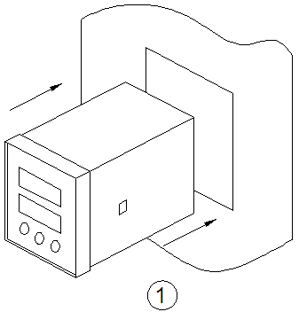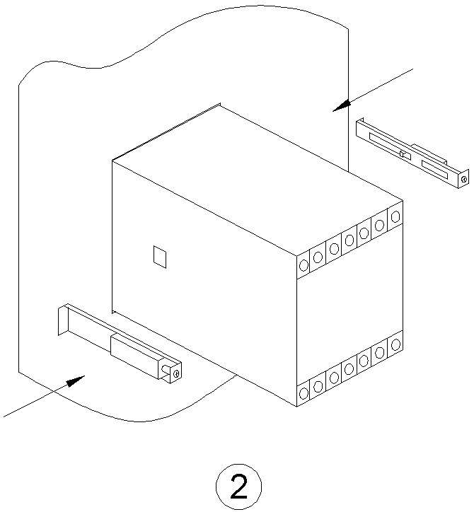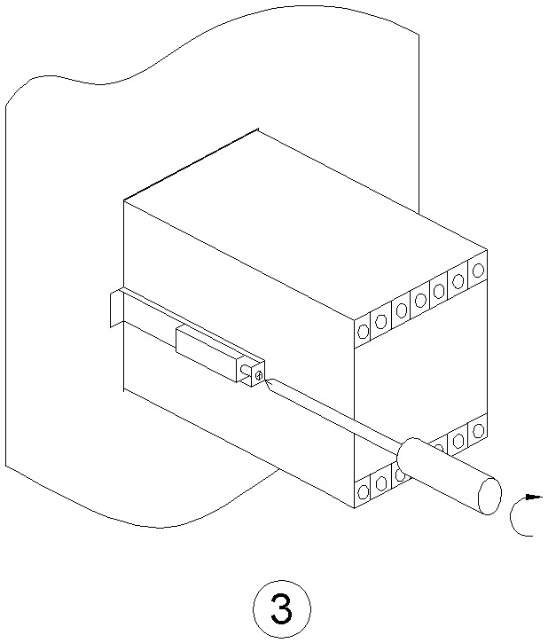

**Notes:**

1. The controller must not be power on until this is completely installed;

2. Panels shall not exceed 12 mm maximum thickness, if more than this range, please consider using the rail mounting.

## **4.2.- Connection Drawing for the WSK-72-W1S1K3**

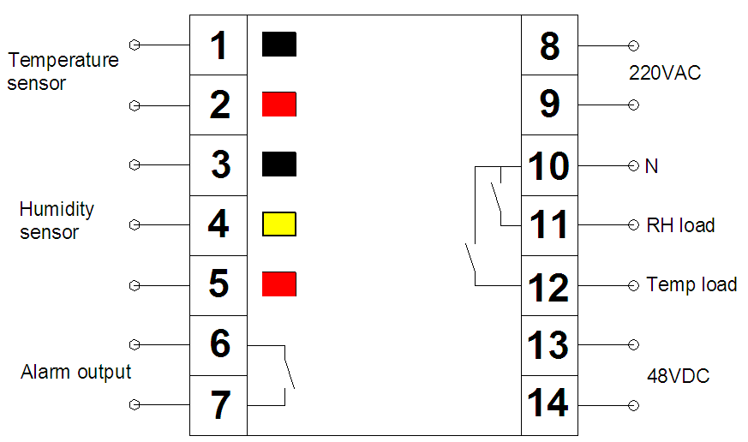

*1.- connect temperature sensor* ***BLACK*** *wire*

*2.- connect temperature sensor* ***RED*** *wire*

*3.- connect humidity sensor* ***BLACK*** *wire*

*4.- connect humidity sensor* ***YELLOW*** *wire*

*5- connect humidity sensor* ***RED*** *wire*

*6,7- connect to alarm output (Dry contact)*

*8- power supply* ***(+)***

*9- power supply* ***(- )***

*10- connect to* common neutral

*11- connect to humidity load* ***(+)***

*12- connect to temperature load* ***(+)***

*13- DC power supply* ***(+)***

*14- DC power supply* ***(-)***

**Notes:**

Temperature load and humidity load use the

common neutral pin (**10**)

That mean temperature load will connect pin (**9**) for the *positive* and pin (**12**) for the *negative*

Do read and full understanding of the controller wiring, if can not sure the connection, please contact BLUE JAY technical support **tech@cqbluejay.com** for more help.

# **5.- OPERATION MODE**

When the WSK-72 Series controller is powered up, all the LED indicator will on, and controller start self- test to check the sensor status. After some seconds, the controller is ready for operation and shows one of the available screens.

**Note:** If there is any sensor off line, the display will show “ ”to indicate the sensor failure.

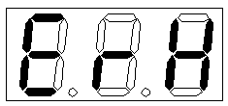

|  |  |
| --- | --- |
|  | **Up key:** Press this key to increase values displayed on the display. Hold down this key to speed up the incremental action.  **Down key:** Press this key to decrease values displayed on the display. Hold down this key to speed up the decrements. |
|  | **Menu key:** Pressing the "Menu" key the can open the programming menu and return to previous menu. |
|  | **Enter key:** Pressing the “Enter” key, you exit it with saving any modification that you might have done, in menu operation press “Enter” key; user can go to the next menu. |

# **6.- SETUP PROCEDURE**

The SETUP procedure of the WSK-72-W1S1K3 is performed by means of several SETUP options.

Once into the SETUP, use the keyboard to select different options and enter required variables:

1. Password enter

2. Set the temperature control value

3. Set the humidity control value

4. Set the control mode

5. Set the up limit alarm value

6. Set the low limit alarm value

## **6.1.- Password enter**

A 3-figure password is required to be entered (in case that this password is not correct, will not be set on the meter).

At normal display mode, press “ ” to enter the programming mode, meter display, then press ; Controller display “ ”,

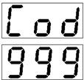

Ask for the password. Press and to increase or decrease the number, to switch password. After password switch press “ ” to confirm the input.



If password is correct, meter can enter next setting.

## **6.2.- Temperature control value**

In this section, user can set value of temperature.

**6.2.1.- Set temperature control value**

After password, press key “ ” to go to the next menu, the display will show:

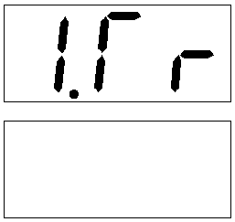

Use and to set the temperature control value, the range is from -40 to 99°C.



**6.2.2.- Set temperature hysteresis value**

Then press key “ ” again, controller ask for set temp. hysteresis, the display will show:

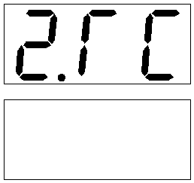

Use and to set the temp. hysteresis value, the range is from 1 to 9.



**6.2.3.- Set temperature compensation value**

Then press key “ ” to controller ask for set temp. compensation, the display will show:

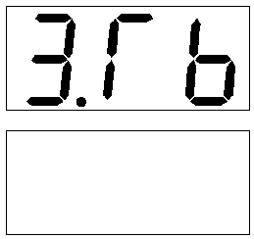

Use and to set the temp. compensation value, the range is from -9.9 to 9.9.



**Notes:**

Each piece of sensor produced by Blue Jay Technologies Co., Ltd is 100% tested to exacting specifications. But the in the normal use condition, the measurement value will be a slight deviation. For ensure the controllerrunning well, users schedule maintenance personnel, more details please refer to **Chapter 8****.**

## **6.3.- Humidity control value**

In this section, user can set value of humidity.

**6.3.1.- Set humidity control value**

After temperature compensation set, press key “ ” to go to the next menu, the display will show:

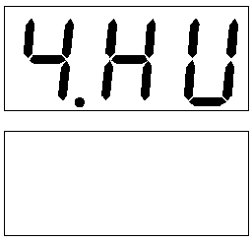

Use and to set the humidity control value, the range is from -40 to 99°C.



**6.3.2.- Set humidity hysteresis value**

Then press key “ ” again, controller ask for set humidity hysteresis, the display will show:

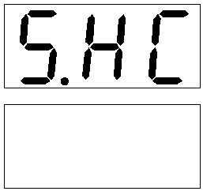

Use and to set the humidity hysteresis value, the range is from 1 to 9.



**6.3.3.- Set humidity compensation value**

Then press key “ ” to controller ask for set humidity compensation, the display will show:

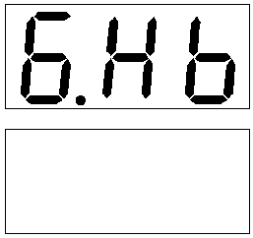

Use and to set the humidity compensation value, the range is from -9.9 to 9.9.



**Notes:**

Each piece of sensor produced by Blue Jay Technologies Co., Ltd is 100% tested to exacting specifications. But the in the normal use condition, the measurement value will be a slight deviation. For ensure the controllerrunning well, users schedule maintenance personnel, more details please refer to **Chapter 8****.**

## **6.4.- Control mode setting**

WSK-72 series controller have 9 type control mode as the following:

0: Heating type

1: Cooling type

In programming mode, press key “ ” to choose the control mode setting, the display will show:

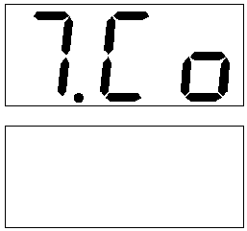

Use and to choose control mode, the range is from 0 to 9.



## **6.5.- Communication setting**

WSK-72 series controller can use RS485 to communication of other device, so there is an address coding to locate each device, BJ-S series controller support 247 device connecting.

In programming mode, press key “ ” to choose the control mode setting, the display will show:

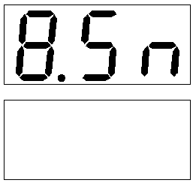

Use and to choose communication address, the range is from 1 to 247.



**Note:**

**Not all the WSK-72 series controller has RS485 port, please check the label on product. If your controller does not have the RS485 port, please pass in this section.**

## **6.6.- Temperature alarm setting**

WSK-72 Have independent relay for alarm output, use can set temperature alarm value, when the temperature exceeds the set value, relay will action.

**6.6.1.- Set upper limit value**

In programming mode, press key “ ” to choose the alarm control setting, the display will show:

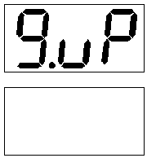

Use and to choose alarm upper limit, the range is from 0.0~99.9.



**6.6.2.- Set lower limit value**

In programming mode, press key “ ”to choose the alarm control setting, the display will show:

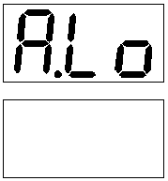

Use and to choose alarm lower limit, the range is from 0.0~99.9.



# **7.- SAFETY CONSIDERATIONS**

All installation specification described at the previous chapters named: **SPECIFICATIONS, INSTALLATION, OPERATION MODES, and SETUP PROCEDURE**



Note that with the controller powered on, the terminals could be dangerous to touching and cover opening actions or elements removal may allow accessing dangerous parts. This controller is factory-shipped at proper operation condition.

# **8.- MAINTENANCE**

The BJ-S42 series controller need to calibration the temperature sensor an humidity sensor in schedule maintenance.

The precision and reliability is very important. We suggested that maintain these sensors in every 3 months:

Step 1: Use a standard meter, which temperature precision is 0.1°C and humidity precision is 3%, to measure the data near the sensors, and recorded for each parameter.

Step 2: Check the displayed real-time sampling value of T, H to compare with the standard value ST, SH.

If the temperature measurement error is more than 1 ℃ and the humidity measurement error is more than 5%

Please enter the setup menu, and modify ***3. Tb*** and ***6.Hb.***

Before any adjustment, replacement, maintenance or repairing operation is carried out, the controller must be disconnected from any power supply source.

When any protection failure is suspected to exist, the controller must be immediately put out of service. The controller’s design allows a quick replacement in case of any failure.

For any inquiry about the instrument performance or any failure,

contact to Blue Jay’s technical service.

*Blue Jay - After-sales service*

E-mail: tech@cqbluejay.com